

Use Case Specification: CSR eCL Outlier Feed
For

eCoaching Log

Change History Log

Date | Version | Description | Author
09/22/2014 | 1.0 | Initial Document | Doug Stearns
12/01/2014 | 1.1 | P13891 – eCL Original Hierarchy  Inserted 3.25, 3.26, following items re-numbered  Modified Figure 1 | Doug Stearns
12/18/2014 | 1.2 | P14028 – eCL OMR FFM T2 Transfers  Updated 3.24 to add TR2 | Doug Stearns
04/30/2015 | 1.3 | P14818 – eCL Low CSAT Data Feed  Added alternate flows 4.4, 4.5, 4.6 and updated figure 1 | Doug Stearns
09/08/2015 | 1.4 | TFS644 – eCL Inappropriate ARC Escalation  Updated or added the following:  3.6  3.24  4.4.1  4.7  updated figure 1 – page 2 | Doug Stearns
9/27/2015 | 1.5 | TFS644 – eCL Inappropriate ARC Escalation  Updated 4.4 for clarity after review (Page 9) | Lisa Stein

Table of Contents

1. Brief Description 6
2. Participating Actors 6
2.1 Primary 6
2.2 Secondary 6
3. Basic Flow of Events 7
3.1 System process executes at the scheduled time. 7
3.2 Input file accessed from appropriate folder. 7
3.3 eCoaching Log information is read from the input file. 7
3.4 Assign the coaching log Program from the input Program. 7
3.5 Assign 212 as the value of the coaching log source id. 7
3.6 Assign the coaching log status from the input Form Status. 7
3.7 Assign the coaching log Site ID from the Employee record Site ID. 7
3.8 Assign the coaching log Employee LAN ID from the input CSR (LAN ID). 7
3.9 Assign the coaching log Employee ID from the Employee record Employee ID when a match is found with the input CSR (LAN ID). 7
3.10 Assign 999999 as the value of the coaching log Submitter ID. 7
3.11 Assign the coaching log Event Date from the input EventDate. 7
3.12 Assign 0 as the value for whether an Avoke ID is associated with the input record. 7
3.13 Assign 0 as the value for whether a NGD Activity ID is associated with the input record. 7
3.14 Assign 0 as the value for whether an UCID is associated with the input record. 7
3.15 Assign 0 as the value for whether a Verint ID is associated with the input record. 7
3.16 Assign the coaching log Description from the input txtDescription. 7
3.17 Assign the coaching log Submitted Date from the input Submitted Date. 8
3.18 Assign the coaching log Start Date from the input Evaluation Date. 8
3.19 Assign 0 as the value of whether this coaching log is Acknowledged. 8
3.20 Assign 0 as the value of whether this is a Customer Service Escalation. 8
3.21 Assign the coaching log Report ID from the input numReportID. 8
3.22 Assign the coaching log Report Code from the input strReportCode. 8
3.23 Assign 1 as the value of the coaching log Module ID. 8
3.24 Assign OMR / Exceptions as the value of the coaching log Reason and a three letter value based on input Report Code as the value of the coaching log sub-reason. 8
3.25 Assign value of employee’s supervisor 8
3.26 Assign value of employee’s manager 8
3.27 Submit the CSR Outlier Management Report eCoaching Log 8
4. Alternative Flows 9
4.1 Assign the coaching log Program. [Step 3.4] 9
4.2 Employee Not Found. [Step 3.9, 4.4.2] 9
4.3 Duplicate eCoaching Logs. [Step 3.21, 3.22] 9
4.4 Employee ID/LAN ID. [Step 3.8, 3.9] 9
4.5 Low CSAT Description. [Step 3.16] 9
4.6 Manager ID. [Step 3.26] 10
4.7 Supervisor Review Description. [Step 3.16] 10
5. Preconditions 10
5.1 Outlier Management Report eCoaching Log input file exists and is available. 10
5.2 eCoaching Log database available. 10
5.3 eCoaching Log database populated with correct and current hierarchy information for CSR, Supervisors, Managers. 10
6. Postconditions 11
6.1 eCoaching Log submitted. 11
7. Assumptions and Dependencies 11
7.1 Input file is processed every day. 11
8. Business Rules 11
8.1 none 11
9. Technical Requirements 11
9.1 none 11
10. Activity Diagrams 12

Table of Figures
Figure 1 – CSR Outlier Management Report eCL Submission 11

Brief Description
Allow eCoaching Logs for call center Customer Service Representatives to be submitted through Outlier Management Report data feed.

Participating Actors

Primary

System process

Customer Service Representatives

Supervisors

Secondary

Managers

Basic Flow of Events

System process executes at the scheduled time.

Input file accessed from appropriate folder.

eCoaching Log information is read from the input file.

Assign the coaching log Program from the input Program.

Assign 212 as the value of the coaching log source id.

Assign the coaching log status from the input Form Status.

Assign the coaching log Site ID from the Employee record Site ID.

Assign the coaching log Employee LAN ID from the input CSR (LAN ID).

Assign the coaching log Employee ID from the Employee record Employee ID when a match is found with the input CSR (LAN ID).

Assign 999999 as the value of the coaching log Submitter ID.

Assign the coaching log Event Date from the input EventDate.

Assign 0 as the value for whether an Avoke ID is associated with the input record.

Assign 0 as the value for whether a NGD Activity ID is associated with the input record.

Assign 0 as the value for whether an UCID is associated with the input record.

Assign 0 as the value for whether a Verint ID is associated with the input record.

Assign the coaching log Description from the input txtDescription.

The following characters from the input record will be replaced with the corresponding string of characters:
& | &amp;
< | &lt;
> | &gt;
` | &#39;
" | &quot;
‘ | &lsquo;
’ | &rsquo;
’ | &prime;
? | &Prime;
“ | &ldquo;
” | &rdquo;
- | &ndash;

Assign the coaching log Submitted Date from the input Submitted Date.

Assign the coaching log Start Date from the input Evaluation Date.

Assign 0 as the value of whether this coaching log is Acknowledged.

Assign 0 as the value of whether this is a Customer Service Escalation.

Assign the coaching log Report ID from the input numReportID.

Assign the coaching log Report Code from the input strReportCode.

Assign 1 as the value of the coaching log Module ID.

Assign OMR / Exceptions as the value of the coaching log Reason and a three letter value based on input Report Code as the value of the coaching log sub-reason.

The following values are possible for sub-reasons:
CAN
DFQ
OPN
ISQ
OSC
ACW
AHT
SPI
ACO
IAE
IDE
IEE
INF
ISG
LCS
NIT
RME
SLG
TRN
TR2
IAT

Assign value of employee’s supervisor

Assign value of employee’s manager

Submit the CSR Outlier Management Report eCoaching Log

Alternative Flows

Assign the coaching log Program. [Step 3.4]

When input Program Name is not present, then assign the coaching log Program from the employee record.

Continue with step 3.5 above.

Employee Not Found. [Step 3.9, 4.4.2]

When input Employee LAN ID match is not found in the Employee records reject the input record.

Continue with Step 3.10 above.

Duplicate eCoaching Logs. [Step 3.21, 3.22]

When input Report ID and Report Code match an existing coaching log’s Report ID and Report Code reject the input record.

Continue with Step 3.23 above.

Employee ID/LAN ID. [Step 3.8, 3.9]

When input Report ID is LCS (Low CSAT), IAE (Inappropriate ARC Escalation), IAT (Inappropriate ARC Transfer) then assign the coaching log Employee LAN ID from the input Employee ID.

Assign the coaching log Employee LAN ID from the Employee record LAN ID when a match is found with the input Employee ID.

Continue with Step 3.10 above.

Low CSAT Description. [Step 3.16]

When input Report ID is LCS (Low CSAT), then assign the coaching log Description by appending the input Description to the text “The call associated with this Low CSAT is Verint ID: “

The following characters from the input record will be replaced with the corresponding string of characters:
& | &amp;
< | &lt;
> | &gt;
` | &#39;
" | &quot;
‘ | &lsquo;
’ | &rsquo;
’ | &prime;
? | &Prime;
“ | &ldquo;
” | &rdquo;

Continue with Step 3.17 above.

Manager ID. [Step 3.26]

When input Report ID is LCS (Low CSAT), then assign the coaching log Manager ID from the input Manager ID.

Continue with Step 3.27 above.

Supervisor Review Description. [Step 3.16]

When input Report ID is IAE (Inappropriate ARC Escalation), IAT (Inappropriate ARC Transfer), then assign the coaching log Description by appending the input Description to one of the following text based on report code.

OMR Report Code | Preceding Sentence
IAE | “You are receiving this eCL because the ARC received an Inappropriate Escalation for this CSR. Please review the Verint Call, NGD call record and coach as appropriate.”
IAT | “You are receiving this eCL because the ARC received an Inappropriate Transfer from this CSR. Please review the Verint Call, NGD call record and coach as appropriate.”

This should be followed by values in CD1 and CD2 prior to saving in the database.

The following characters from the input record will be replaced with the corresponding string of characters:
& | &amp;
< | &lt;
> | &gt;
` | &#39;
" | &quot;
‘ | &lsquo;
’ | &rsquo;
’ | &prime;
? | &Prime;
“ | &ldquo;
” | &rdquo;

Continue with Step 3.17 above.

Preconditions

Outlier Management Report eCoaching Log input file exists and is available.

eCoaching Log database available.

eCoaching Log database populated with correct and current hierarchy information for CSR, Supervisors, Managers.

Postconditions

eCoaching Log submitted.

Assumptions and Dependencies

Input file is processed every day.

Business Rules

none

Technical Requirements

none

Activity Diagrams
Below is the activity diagram for the use case that provides a visual depiction of the flow of events.

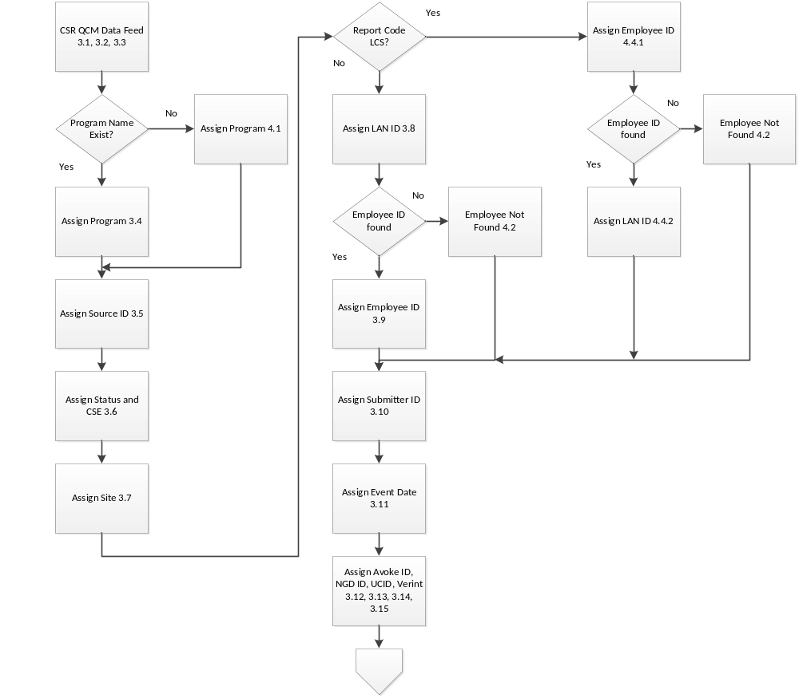

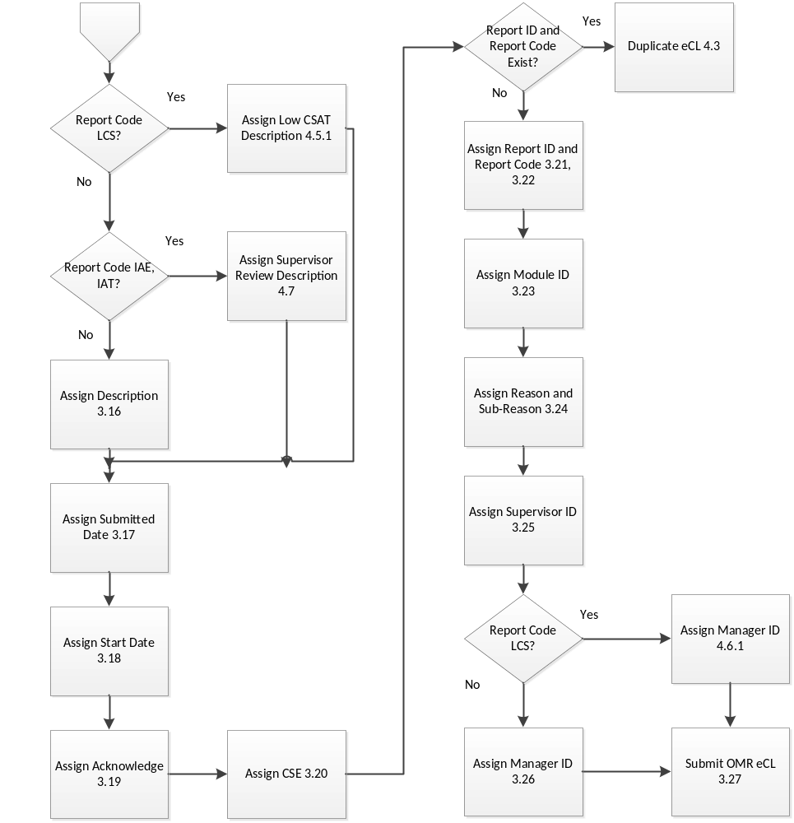

Figure 1 – CSR Outlier Management Report eCL Submission

